**Year 12 ATAR PHYSICS**

**Practical Test WAVES AND QUANTA**

**Part A: DETERMINING PLANCK’S CONSTANT**

**Marks: /20**

**ANSWERS**

**Equipment operation:**

**(2 marks, -1 for each request for help, unless equipment problem related)**

**EXAMPLE DATA**

|  |  |  |
| --- | --- | --- |
| Vth | (Read from the dial) | Frequency (f) |
| 1. **Data column** |  | 1. **Calcs column** |
| 2.317 V | 465 nm | 6.45 X 1014 Hz |
| 1.837 | 520 | 5.77 |
| 1.584 | 594 | 5.05 |
| 1.289 | 620 | 4.84 |
| 1.344 | 660 | 4.55 |
| 0.859 | 880 | 3.41 |
| 0.792 | 940 | 3.19 |

(2 marks)

1. Plot V vs f results on the following graph (grid over the page). (4 marks)

**(1) scales (1) labels (2) accurate plotting**

2. Line of best fit ignoring outliers (1 mark)

**GRAPH:**

1.0 2.0 3.0 4.0 5.0 6.0 7.0 8.0 9.0

2.5

2.0

1.5

1.0

0.5

0

V

O

L

T

S

FREQUENCY X 1014 HZ

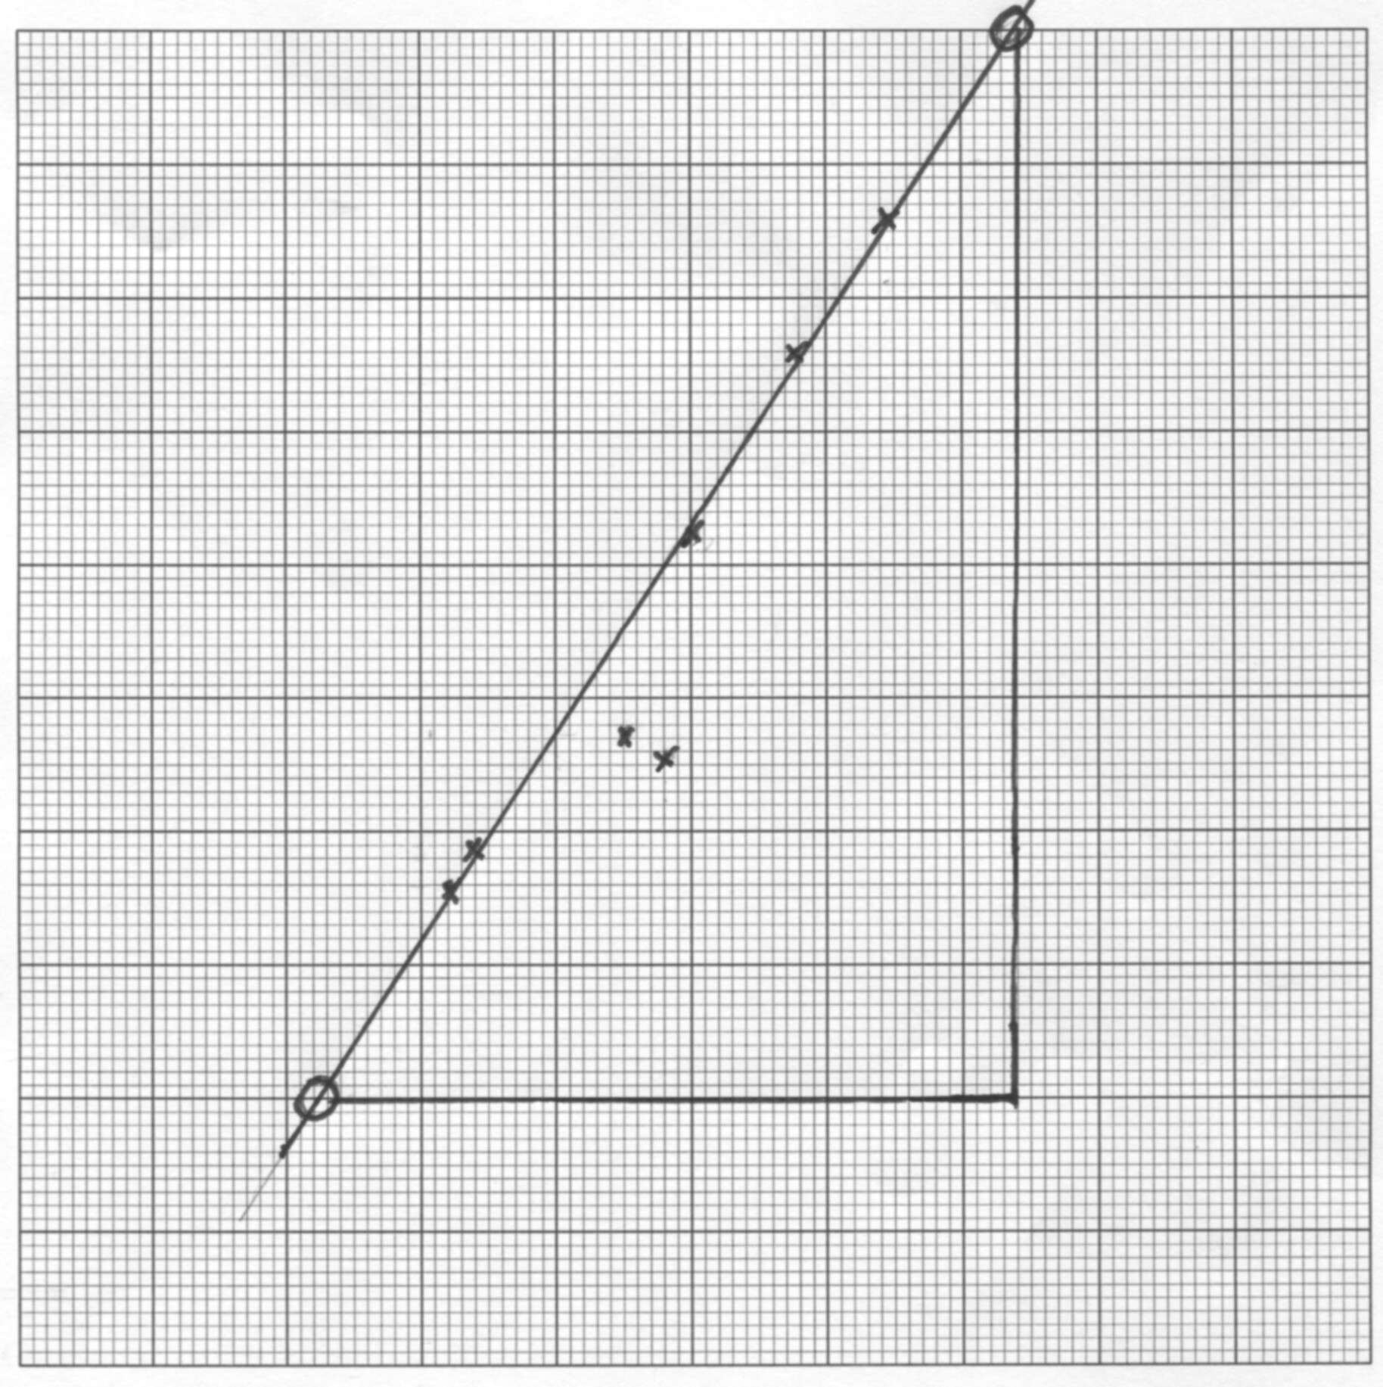

3. Calculate the gradient showing clearly on the graph where you have taken the points.

(3 marks)

**Gradient = (2.5 - 0.5) (1) method shown on graph**

**(7.4 – 2.3) x 1014**

**= 3.85 x 10-15 Vs (1) ANS (1) units [VHz-1 ok!]**

4. Use the gradient to calculate h. (4 marks)

**eVth = hf , so Vth = hf / e**

**gradient = h/e**

**h = gradient x e = 3.85 x 10-15 x 1.6 x 10-19**

**= 6.2 x 10-34 Js (1) (1) unit**

**2 sig figs (1)**

**Range: 6.0 - 6.4 x10-34 Js (1) Ans in range**

5. List one random error and one systematic error which may occur when conducting the above experiment: (2 marks)

**Any reasonable answer, must be in correct category, such as:**

**RANDOM: Reading display on digital meters**

**Drawing line of best fit**

**SYSTEMATIC:**

**Resistance in wires (poor connections): (Random??)**

**Calibration of meters**

**Inaccurate value for wavelength of LEDS.**

6. Identify two methods which would help to minimise the errors. (2 marks)

**Use higher quality meters**

**Use high quality connectors, expand banana leads etc**

**Check wavelengths with spectrometer.**

**Repeat lab or combine class results.**